**Svi 5**

Model 1, backward ols

Adj. R-Squared 0.734

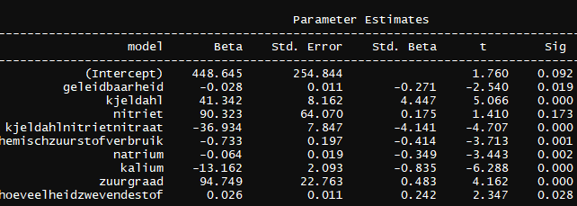

Model 2, zonder nitriet en hoeveelheid zwevende stof

Adjusted R-squared: 0.6889

Estimate Std. Error t value Pr(>|t|)

(Intercept) 496.26771 260.89614 1.902 0.069217 .

geleidbaarheid -0.02574 0.01159 -2.220 0.036128 *

kjeldahl 33.98894 8.02198 4.237 0.000289 ***

kjeldahlnitrietnitraat -28.92607 7.46180 -3.877 0.000719 ***

chemischzuurstofverbruik -0.69316 0.20937 -3.311 0.002934 **

natrium -0.06649 0.01997 -3.329 0.002805 **

kalium -11.72437 2.13016 -5.504 1.17e-05 ***

zuurgraad 99.85160 23.53553 4.243 0.000285 ***

Model 3, zonder kjeldahl en kjeldahlnitrietnitraat

Adjusted R-squared: 0.43

Estimate Std. Error t value Pr(>|t|)

(Intercept) 600.39560 351.87696 1.706 0.09988 .

geleidbaarheid -0.03021 0.01541 -1.960 0.06075 .

chemischzuurstofverbruik -0.36229 0.26337 -1.376 0.18069

natrium -0.05557 0.02653 -2.095 0.04607 *

kalium -7.13686 2.46692 -2.893 0.00762 **

zuurgraad 56.24391 29.44244 1.910 0.06718 .

**Svi30**

Model 1, backward ols

Adjusted R-squared: 0.6757

Estimate Std. Error t value Pr(>|t|)

(Intercept) 39.123486 104.608347 0.374 0.711985

geleidbaarheid -0.016167 0.004901 -3.299 0.003274 **

kjeldahl 12.067996 3.120030 3.868 0.000832 ***

kjeldahlnitrietnitraat -9.729370 2.938917 -3.311 0.003182 **

chemischzuurstofverbruik -0.434604 0.119178 -3.647 0.001422 **

biologischzuurstofverbruik 0.956972 0.703679 1.360 0.187619

natrium -0.013905 0.007509 -1.852 0.077500 .

kalium -3.190375 0.805399 -3.961 0.000663 ***

zuurgraad 39.880292 9.155224 4.356 0.000253 ***

hoeveelheidzwevendestof 0.005270 0.004564 1.155 0.260562

Model 2, verwijderen parameters p > 0.05, biologischzuurstofverbruik (0.188), natrium (0.188), hoeveelheidzwevendestof (0.261).

Adjusted R-squared: 0.6042

Estimate Std. Error t value Pr(>|t|)

(Intercept) -87.78508 80.20198 -1.095 0.284148

geleidbaarheid -0.01571 0.00466 -3.371 0.002435 **

kjeldahl 11.72891 3.31663 3.536 0.001611 **

kjeldahlnitrietnitraat -9.55385 3.08565 -3.096 0.004786 **

chemischzuurstofverbruik -0.29496 0.08572 -3.441 0.002046 **

kalium -2.70422 0.86996 -3.108 0.004646 **

zuurgraad 40.12691 9.68750 4.142 0.000344 ***

---

Signif. codes: 0 ‘***’ 0.001 ‘**’ 0.01 ‘*’ 0.05 ‘.’ 0.1 ‘ ’ 1

Residual standard error: 21.05 on 25 degrees of freedom

Multiple R-squared: 0.6808, Adjusted R-squared: 0.6042

F-statistic: 8.886 on 6 and 25 DF, p-value: 3.076e-05

Model 3, zonder kjeldahl en kjeldahlnitrietnitraat

Adjusted R-squared: 0.3099

Coefficients:

Estimate Std. Error t value Pr(>|t|)

(Intercept) 5.117569 101.646320 0.050 0.96022

geleidbaarheid -0.017538 0.006081 -2.884 0.00762 **

chemischzuurstofverbruik -0.157433 0.105848 -1.487 0.14851

kalium -1.225576 0.979060 -1.252 0.22138

zuurgraad 23.267777 11.857659 1.962 0.06012 .